**הכרות עם הכליםStage 0:**

**This is the ERD that we obtained with the ERD’s application.**

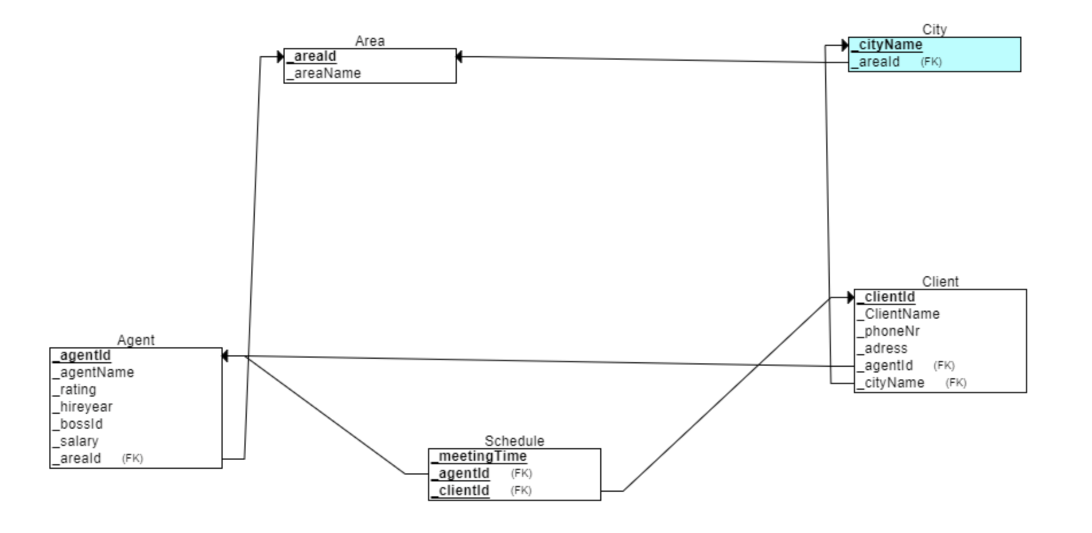

**Here the schemas that we obtained with the application.**

CREATE TABLE Area

(

_areaId NUMERIC(3) NOT NULL,

_areaName VARCHAR(20) NOT NULL,

PRIMARY KEY (_areaId)

);

CREATE TABLE City

(

_cityName VARCHAR(20) NOT NULL,

_areaId NUMERIC(3) NOT NULL,

PRIMARY KEY (_cityName),

FOREIGN KEY (_areaId) REFERENCES Area(_areaId)

);

CREATE TABLE Agent

(

_agentId NUMERIC(9) NOT NULL,

_agentName VARCHAR(20) NOT NULL,

_rating NUMERIC(2) NOT NULL,

_hireyear NUMERIC(4) NOT NULL,

_bossId NUMERIC(9) NOT NULL,

_salary FLOAT NOT NULL,

_areaId NUMERIC(3) NOT NULL,

PRIMARY KEY (_agentId),

FOREIGN KEY (_areaId) REFERENCES Area(_areaId)

);

CREATE TABLE Client

(

_clientId NUMERIC(9) NOT NULL,

_ClientName VARCHAR(20) NOT NULL,

_phoneNr VARCHAR(10) NOT NULL,

_adress VARCHAR(25) NOT NULL,

_agentId NUMERIC(9) NOT NULL,

_cityName VARCHAR(20) NOT NULL,

PRIMARY KEY (_clientId),

FOREIGN KEY (_agentId) REFERENCES Agent(_agentId),

FOREIGN KEY (_cityName) REFERENCES City(_cityName)

);

CREATE TABLE Schedule

(

_meetingTime DATE NOT NULL,

_agentId NUMERIC(9) NOT NULL,

_clientId NUMERIC(9) NOT NULL,

PRIMARY KEY (_meetingTime, _agentId, _clientId),

FOREIGN KEY (_agentId) REFERENCES Agent(_agentId),

FOREIGN KEY (_clientId) REFERENCES Client(_clientId)

);

**This is the code that refers to the ERD and the relational schemas obtained.**